The Geometry of Derivatives
https://www.youtube.com/watch?v=S0_qX4VJhMQ
Materials: Base 10 Blocks (same color different colors) or Algebra Tiles
Use Base 10 Blocks or Algebra Tiles as a demo in class. Follow up with the video link after class.
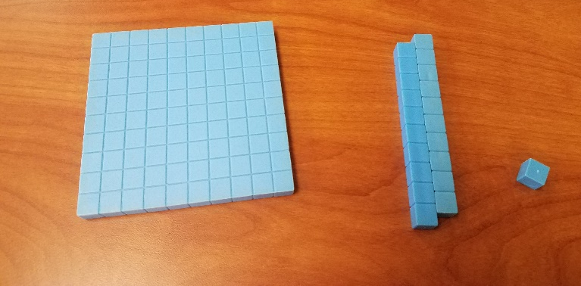

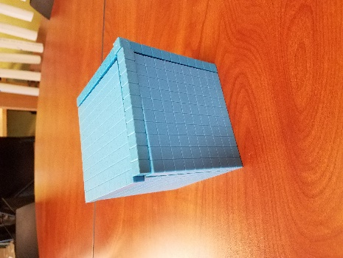 | 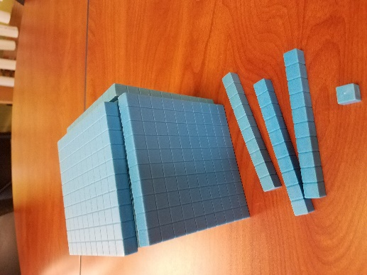 | 